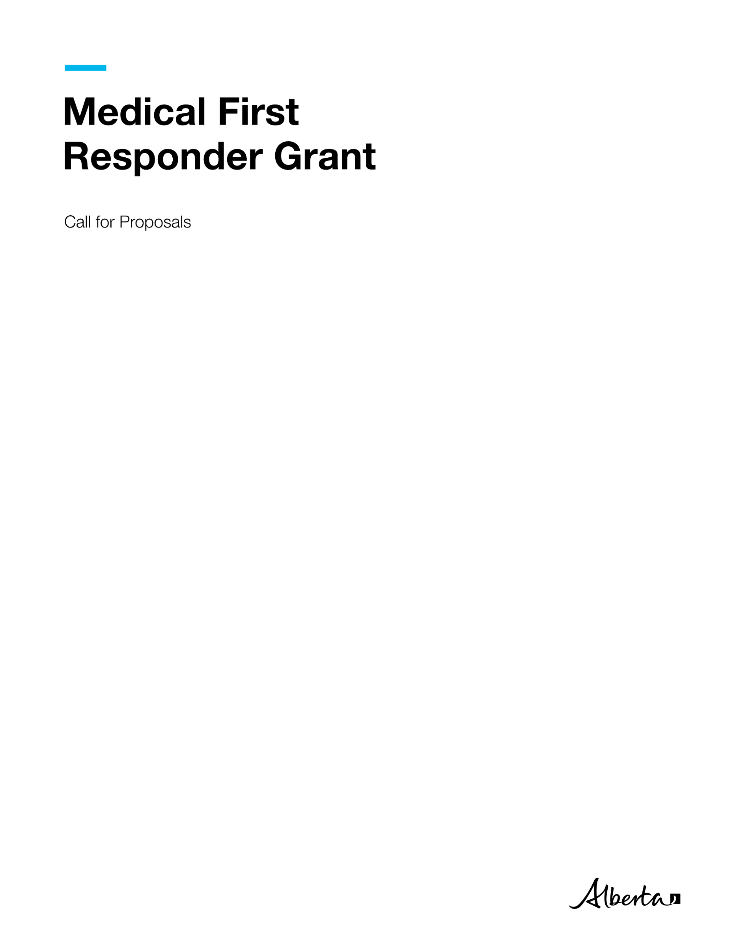
Medical First Responder Grant | Ministry of Hospital and Surgical Health Services
© 2026 Government of Alberta | October 13, 2026



Contents
Call for Proposals 1
Medical First Responder Grant Application 1
Project Description 1
Purpose 1
Service 1
Rationale 2
Who can apply 2
Eligibility Criteria 2
Application Process 2
Evaluation and Approval Process 2
Timeline 3
Proposal Coversheet 4
Grant Applicant Information 4
Project Information 5
Proposal Template 5
Project Plan 8
Budget Worksheets 9
Financial Statement 10
Proposal Evaluation Considerations 11
Expense Guidelines 12
Grant Proposal Checklist 13

Call for Proposals

Medical First Responder Grant Application
The information you provide on and with this application is collected and used under the authority of the Protection of Privacy Act (POPA). The information you provide will be used by Hospital and Surgical Health Services (HSHS) for the purposes of processing your application for the Medical First Response (MFR) Grant. The information collected will be managed in accordance with POPA. If you have any questions about the collection, use or disclosure of this information, contact the Emergency Health Services (EHS) Branch by email at EHSgrant@gov.ab.ca.

The Government of Alberta is providing one-time funding of up to $50,000 to support rural and remote communities, as well as First Nations, Métis and Inuit communities (including First Nations, Tribal Councils and Treaty Organizations, Metis Settlements General Council, Metis Settlements, Métis Nation of Alberta, and Indigenous-serving non-profit organizations) that would like to establish a Medical First Response (MFR) program within their community or expand existing MFR programs. The grant is intended to assist communities in the development of MFR response capacity in their communities. The grant would assist in the purchase of new equipment, training for staff and volunteers, and other eligible supports. The MFR Program is provided primarily by municipal fire rescue agencies or local community groups, allowing for quick response to emergencies and delivery of patient care until Emergency Health Services (EHS) can arrive.

Please submit a funding proposal to EHSgrants@gov.ab.ca. Applicants must be legal entities (for example, a company/organization or a municipality). Please complete the grant application and proposal by clearly defining the scope of work, detailed breakdown of project costs and a reasonable timeline for achieving project milestones. For assistance in completing this grant application, please contact the EHS Branch at EHSgrants@gov.ab.ca.

Project Description

The MFR Grant provides one-time funding to help eligible communities establish a new MFR program or expand existing MFR capacity. Funding will support communities in building their ability to respond effectively to medical emergencies and strengthen Alberta's overall pre-hospital emergency response system.

Purpose

The purpose of the grant is to increase MFR capacity in rural, remote, First Nations, Métis and Inuit communities by supporting the development of new programs and expansion of existing programs.

Service
Successful applicants may receive grants of up to $50,000 per agency or community, with total program funding available of up to $800,000. Eligible expenditures include the purchase of equipment, training for staff and volunteers, and other supports necessary to implement and sustain the program.

Rationale

Improving access to emergency care in rural and remote communities is a government priority. MFR programs can provide an earlier response to medical emergencies and deliver patient care until EHS arrives. The grant will also support Alberta's health workforce by giving first responders opportunities to build skills and experience that may support pathways into paramedic careers while allowing them to train and serve in their local communities.

Who can apply
Municipalities, rural and remote communities, First Nations, Métis and Inuit communities (including First Nations, Tribal Councils and Treaty Organizations, Metis Settlements General Council, Metis Settlements, Métis Nation of Alberta, and Indigenous-serving non-profit organizations) who meet the eligibility criteria can apply for this grant.

Eligibility Criteria
Grant funding will be distributed based on the following priorities:

- Priority 1
  - Communities that do not currently have an MFR program.
  - All First Nations, and Métis communities.
  - Communities with less than 5000 Alberta residents.
- Priority 2
  - Communities with existing MFR programs
  - Communities with less than 7500 Alberta residents
- Priority 3
  - Previous recipients of the MFR Grant
  - Communities with greater than 7500 Alberta residents

Applicants may meet more than one priority category. Where this occurs, Hospital and Surgical Health Services may consider overall alignment with program objectives, demonstrated community need, geographic considerations, organizational readiness, and available funding when determining funding decisions. Meeting the eligibility criteria or submitting an application does not guarantee funding.
All grant recipients must be able and willing to participate in the Alberta MFR program. Participation in this program is a grant requirement.
Submission of an application does not guarantee funding. Hospital and Surgical Health Services reserves the right to approve, partially approve or decline funding requests based on program priorities, eligibility requirements, application quality, and available funding.

Application Process
Applicants will have 6 weeks to develop and submit their completed funding proposal including pages 4 to 10, and page 13.

Evaluation and Approval Process
Applications will be assessed based on demonstrated community need, alignment with program objectives, organizational readiness, proposed use of funding, anticipated community benefit, and available program funding. The applications will be reviewed by the Government of Alberta EHS Branch, within 4 weeks of closing. Funding will be distributed geographically across the province taking into consideration the priorities of the eligibility criteria above, location, and distance from local EHS, while supporting equitable geographic distribution across the province. Once applications are reviewed and decisions are finalized, the funding will be awarded to the successful applicants.

Timeline
Activity | Timeline | Notes/Templates/Contacts
Submit grant proposal | October 13 to November 24, 2026 (6 weeks) | Email the grant proposal to EHSgrants@gov.ab.ca
Review of grant proposals | November 24 to December 22, 2026 (4 weeks) | HSHS reviews grant proposals.
Project development | January 4 to March 1, 2027  (8 weeks) | Project scope and deliverables to be finalized.
Notify grant recipients | March 1, 2026 to March 15, 2027 | Successful applicants will be notified
Execute grant funding agreement | March 15 to April 12, 2027  (4 weeks) | Grant agreement signed by recipient and HSHS for execution.
Award grant funding | April 12 to May 3, 2027  (3 weeks) | Grant payment sent to the grant recipients.

Proposal Coversheet
Medical First Response Grant April 1, 2026, to March 31, 2027
Submit an electronic copy of the proposal to EHSGrants@gov.ab.ca by 4:30 PM by November 24, 2026

Grant Applicant Information
Incorporated Legal Name of Operator and/or Community; or Name of Business or Organization:

Mailing Address (All correspondence will be sent here):
Project Name
Project Information
Project Contact Name
Title
First name
Last Name
Authorized Signatory
Email Address
Phone Number/ Alternate #
Project Start Date
Project End Date
Type of Organization (please select one):
☐ First Nation/ Metis Settlement
☐ Municipality
☐ Rural and/or Remote Community
☐ Incorporated non-profit organization
☐ Other (please specify)

Is this a collaboration between multiple groups or organizations?
Yes ☐ No ☐
If yes, please list groups/organizations below and ensure completion of the Budget Worksheet - Breakdown by Collaborator:

Project Information
Total amount of funding requested:
Location to be served through this funding:

Proposal Template
Project Summary: Please provide a brief overview of the purpose and scope of the proposed project. Please provide a clear and concise explanation of the project including what the project is, why you propose to do it, the scope of the work that will be done and how it will strengthen and stabilize the paramedic workforce in remote, rural, as well as First Nations, Métis and Inuit communities in Alberta.

Explain how the project for which you are seeking funding will address anticipated community needs.

Explain if there is expectation of future reliance on federal or provincial funding to maintain the project beyond one year.

Organizational history: Include a brief explanation of how the organization was established, its mission, vision and structure, as well as its record of working on related initiatives. Attach a current, dated organizational chart that demonstrates how the proposed project fits into the agency structure. (Max 300 words)

Organizational Capacity: Briefly describe your organization’s capacity to quickly initiate and develop a new MFR program. Additionally, describe how the project activities will be unique and exclusive from existing programs and how the project will be completed by the end of the grant term. (Max 500 words)

Project Intent and Evidence of Need: Provide detail regarding how this project will meet the needs of rural, remote, as well as First Nations, Métis and Inuit communities who lack emergency service capabilities and experience lengthy EHS response times. Identify the main issues of focus and the outcomes the project will achieve. Please describe or illustrate the timelines and project milestones and link the timeline to operational objectives and project outcomes. (Max 300 words)

Project Scope: In point form, summarize the work the project will deliver as well as activities that are not possible within the confines or scope of project.

In Scope | Out of Scope

Constraints - Describe any limitations that may have an impact on the project. (Max 200 words)

Risk Assessment - Identify the risks that could influence the project/program’s success, including those related to scope (purpose/objectives), cost (budget), or schedule. Assess the risks as High, Moderate or Low and describe mitigating strategies.

Risk | Probability | Impact | Response Strategy
What is the name of the Risk? | Is this risk High, Moderate, or Low? | If it happens, what effect will it have? | How will you deal with the risk?
Stakeholder Engagement: How will stakeholders (clients, supporters, collaborators, and community members) be engaged in the project? (Organizations are encouraged to consider ways to engage with local community members, groups, and business owners throughout the project.) (Max 300 words)

Knowledge Mobilization: Describe how project learnings, tools or outcomes could be shared with other communities or partners to support broader EHS workforce improvements in Alberta. (Max 300 words)

Sustainability/Legacy Planning: How will the project be concluded by the end of the grant term? Describe what (if anything) will continue or exist as a resource after the funding has ended. (Max 300 words)

Project Plan
Provide a high-level overview of project objectives, the planned actions and activities that will support the project objectives, and which grant priority they address. Objectives should relate to one or more grant priorities and should be specific, measurable, attainable, realistic, and timely (SMART).

Program Objective:

Activity | Priority Population | Outputs | Expected Outcome | Performance Indicator(s)  (How will you measure achievement of outcome) | Grant Priority Addressed
Program Objective:

Activity | Target/Priority Population | Outputs | Expected Outcome | Performance Indicator(s) | Grant Priority Addressed
Organizations can submit the program project plan using this template or their own document pending the above information is provided.

Budget Worksheets
Please use the categories listed below and ensure both a breakdown by expense and by collaborator (if applicable) is provided. Expense guidelines are provided after the table. An Excel template has been provided in this proposal package.
Organization  (Name of applicant or organization collaborator that will provide services) | Project allocation  (Amount from proposed budget that will be used by this organization) | Services Provided  (Service delivered and the priority population targeted) | Priority Population
 | $
 | $
 | $
 | $
 | $
Requested One-Time Funding: __________________
Breakdown by Collaborator (Only applicable to applications by community collaborations)

Financial Sources
List all the projected financial sources of the project.

Other Sources of Funding | Name of Institution/Funding Type | Type of Financing/Description | Funding Amount
Financial Institution
Other Grants
Company/Community Funds
In-kind support for project and approximate value

Financial Statement
Expenses | Description/ Comments | January 1, 2027 - March 31, 2027 | April 1, 2027 - March 31, 2028 | Total
Recruitment
 |  | $ | $ | $
 |  | $ | $ | $
Project Materials and Supplies
Printing/  Photocopying |  | $ | $ | $
Project supplies |  | $ | $ | $
Client supplies |  | $ | $ | $
Other (specify) |  | $ | $ | $
Eligible Equipment (program specific equipment - please specify)
 |  | $ | $ | $
 |  | $ | $ | $
Training
Courses/Education |  | $ | $ | $
Meetings/Events |  | $ | $ | $
Travel |  | $ | $ | $
Other (Specify) |  | $ | $ | 7
Total Expenses |  | $
Reporting
Recipients must regularly report on the project’s financial status and outcomes achieved. Hospital and Surgical Health Services may request additional information to support program evaluation and accountability requirements. If the project scope or deliverables change after the Grant Agreement is in place, the recipient must contact EHSgrants@gov.ab.ca. Both parties must agree to amend the Grant Agreement to accommodate the changes.

Proposal Evaluation Considerations
Proposals that meet mandatory requirements will be evaluated based on, but not limited to, the following considerations:

Impact
- Proposal aligns with funding priorities targeting rural, remote, as well as First Nations, Métis and Inuit communities.
- Proposal clearly describes the purpose and scope of project and rationale for how proposed activities will address identified needs.
- Proposal provides evidence showing that the desired impact will successfully be facilitated through the suggested activities.
- Proposal explains how the project will strengthen and stabilize the paramedic workforce in remote, rural, and Indigenous communities in Alberta.

Demonstrated Need/ Feasibility
- Applicant provides information on how the community is being impacted by lack of emergency service capabilities and lengthy EHS response times and challenges being experienced among rural, remote, as well as First Nations, Métis and Inuit communities, specific to the proposed project location.
- Proposal and work plan clearly present activities to be undertaken, how goals will be achieved, and the likelihood that the proposed project will achieve its goals or targets in the funding period.
- Activities and services are feasible to implement in the service area context.
- Proposed project complements (or enhances) rather than duplicates existing activities for the population(s) in the service area.

Organizational and Financial Capacity
- Organization (and collaborators if applicable) demonstrates the required expertise and resources to deliver outcomes on time and on budget.
- Applicants demonstrate strong financial and management systems.
- Proposal demonstrates that the project is cost-effective in delivering outcomes.
- Proposed budget meets proposal requirements and provides clear rationale for allocations.

Expense Guidelines
A Grant Recipient may only use grant funding as set out in the grant agreement for expenses that are directly related to the project's activities. If a Grant Recipient is uncertain if a proposed expenditure is an eligible or ineligible expense, they should contact the Alberta Health grant manager prior to making the expenditure.

Eligible expenses include equipment, education, and recruitment.
Non-eligible expenses include staff wages, renovations, vehicles, land and property, infrastructure, and administration fees.

- Compensation-related expenses - Expenses must be for individuals whose duties are directly and primarily related to activities undertaken as part of the project as set out in the grant agreement. Ineligible items include, but are not limited to:
- Discretionary severance and separation packages.

- Travel and subsistence costs - Travel and subsistence costs include reasonable out-of-pocket expenses in accordance with standard Government of Alberta rates for fieldwork, research, and other activities directly related to and necessary to carry out the activities under the project as set out in the grant agreement. Travel and subsistence costs must comply with and must not exceed the maximum allowable under the directive applicable to Government of Alberta employees. Ineligible items include, but are not limited to:
- Commuting costs between residence and place of employment.
- Passport and immigration fees.
- Reimbursement for airfare purchased with personal frequent flyer points.

- Equipment and supplies - Expenses include reasonable costs for the purchase of equipment and supplies, which are directly related to and will be used primarily for the project as set out in the grant agreement. Ineligible items include, but are not limited to:
  - Insurance costs for equipment.
  - Costs of construction, renovation of laboratories, offices.

Grant Proposal Checklist
All applications and proposals must include:
- Completed and signed grant application and grant proposal, including pages 4 to 10, and page 13.
- Evidence of authority to act on behalf of the community and a letter of intent/commitment to participate in the MFR Program.
- All documents must be submitted together as one digital copy.

Declaration
This application must be signed by an authorized representative with full legal authority. The application must be signed and dated before Alberta’s government receives the application and grant proposal package.
- I understand that information in the application form may be disclosed/shared with other funders such as government departments, agencies, and private sector organizations, as required.
- The organization I represent endorses the project.
- As the authorized representative of this community, I confirm that I have reviewed and understand the guidelines of submission for this grant program. I attest that all the information provided in this application is accurate and true to the best of my knowledge.

I, ______________________ (name in full), of the community of ____________, in the Province of Alberta, am the ___________________ (insert position) of _______________ (name of applicant organization).

I hereby certify that I represent the governing body of the applicant organization and am authorized to sign this Grant Application and Proposal Submission.

________________________ ___________________ ____________
Authorized Signing Officer Signature Date

