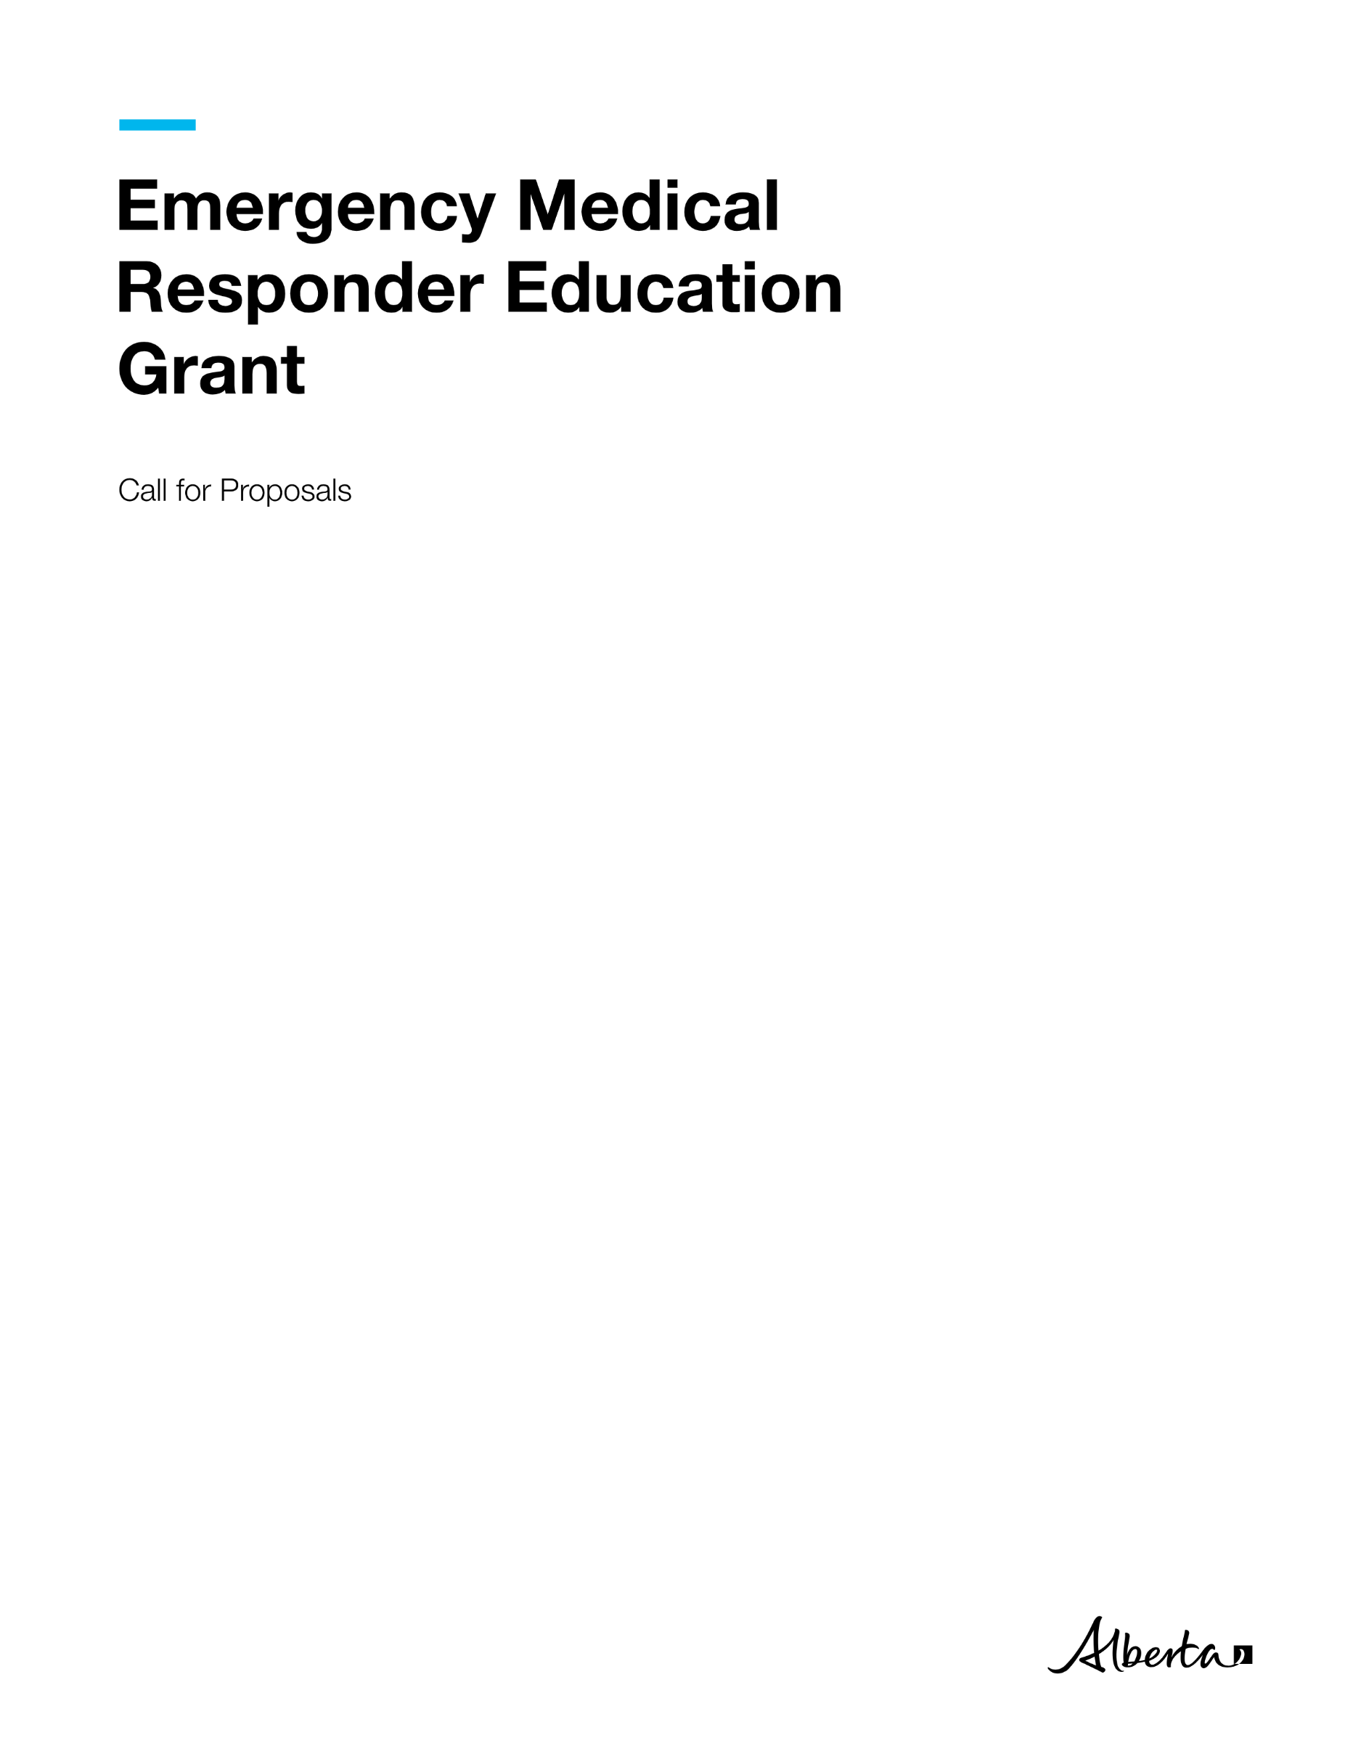
Emergency Medical Responder Education Grant | Hospital and Surgical Health Services
© 2026 Government of Alberta | October 13, 2026



Contents
Call for Proposals 1
Emergency Medical Responder Education Grant Application 1
Project Description 1
Purpose 1
Service 1
Rationale 2
Eligibility Criteria: 2
Application Process 2
Evaluation Process 2
Timeline 3
Proposal Coversheet 4
Grant Applicant Information 4
Proposal Template 5
Project Plan 7
Budget Worksheets 8
Financial Statement 9
Proposal Evaluation Considerations 10
Expense Guidelines 11
Grant Application and Grant Proposal Checklist 12

Call for Proposals

Emergency Medical Responder Education Grant Application
The information you provide on and with this application form is collected and used under the authority of the Protection of Privacy Act (POPA). The information you provide will be used by Hospital and Surgical Health Services (HSHS) for the purposes of processing your application for the Emergency Medical Responder (EMR) Education Grant. The information collected will be managed in accordance with POPA. If you have any questions about the collection, use or disclosure of this information contact the Emergency Health Services (EHS) Branch by email at EHSgrants@gov.ab.ca.
The EMR Education Grant will provide up to $24,000 in funding to eligible organizations in communities located within 100-km radius of an Emergency Health Services (EHS) station. Those applying must be legal entities. The grant is intended to support rural and remote communities, as well as First Nations, Métis and Inuit communities, by increasing access to EMR training and helping attract, train and retain local EHS practitioners to strengthen the overall paramedic workforce in Alberta.
Licensed private or contracted ambulance operators that service rural and remote communities, as well as First Nations, Métis, and Inuit communities, and Indigenous-serving organizations, have six weeks to develop and submit a funding proposal using the grant application and proposal form to EHSgrants@gov.ab.ca.. The proposal must be fully completed by clearly defining the scope of work, including a detailed breakdown of projected costs and providing a reasonable timeline for completing the project activities and reaching project milestones. For assistance in completing this grant application, contact the EHS Branch at EHSgrants@gov.ab.ca.

Project Description
The EMR Education Grant will provide EMR training opportunities for individuals through agencies based in rural, remote, First Nations, Métis and Inuit communities in Alberta. A total of $24,000 is available for approved eligible organizations to assist local residents interested in joining the paramedic workforce, through obtaining their EMR certification.

Purpose
The grant will support Alberta’s health workforce strategy by helping attract and retain new in-community EHS practitioners in rural, remote, First Nations, Métis, and Inuit communities.

Service
The Grants will fund organizations or agencies that express interest in recruiting individuals for in-community training programs that will qualify them to practice as an EMR. Focus will be placed on rural, remote, First Nations, Métis and Inuit communities in Alberta experiencing challenges in attracting and retaining EHS staff. The grants will be used to fund EMR courses, delivered by post-secondary institutions approved by the Alberta College of Paramedics, offering a combination of virtual and in-person training within successful grant recipient communities. Funding may also be used to cover the cost of regulatory college exam fees for participants, but does not include capital expenses, operational and existing costs.

Rationale
Ambulance operators that serve rural, remote, First Nations, Métis and Inuit communities are experiencing challenges in staffing ambulances. These challenges can contribute to longer EHS response times and decreased ambulance availability. The EMR Education Grant is specifically intended to bring community residents into the paramedic profession and support their career development by enabling them to train and remain in their communities. This aims to increase access to health care services for Albertans by improving EHS system capacity.

Eligibility Criteria
Eligibility is limited to organizations that serve Alberta residents and are located within 100 km of an existing EHS station, including:

- Rural and remote communities as defined in the Rural Health Action Plan, 2024-27
- First Nations
- Tribal Councils and Treaty Organizations
- Metis Settlements General Council
- Metis Settlements
- Otipemisiwak Métis Government (Métis Nation of Alberta)
- Indigenous serving non-profit organizations supporting First Nations, Métis, and Inuit peoples
- Previous recipients of the Medical First Responder Grant | Alberta.ca
- Licensed private or contracted ambulance operators in a rural and/or remote community
- Licensed private or contracted ambulance operators in First Nations, and Métis communities
Applicant organizations must:
- Have internet access and devices for each student that are capable of accessing the internet for the online training component
- Have a facility, such as a community centre or gymnasium, to host the in-community practical sessions
- Provide a letter of commitment to partner with a post-secondary institution or EMR training provider approved by the Alberta College of Paramedics

Application Process
- Applicants will have 6 weeks to develop and submit their completed funding proposal including pages 4 to 9, and page 12.

Evaluation Process
The applications will be reviewed by the Government of Alberta’s EHS Branch, within 4 weeks of closing. Funding will be distributed geographically across the province. Priority will be given to communities that have demonstrated challenges attracting and retaining qualified practitioners, while supporting equitable geographic distribution across the province. Once applications are reviewed and decisions are finalized, the funding will be awarded to the successful applicants. Submission of an application does not guarantee funding.

Timeline
Activity | Timeline | Notes/Templates/Contacts
Submit grant proposal | October 13 to November 24, 2026 (6 weeks) | Email the grant proposal to EHSgrants@gov.ab.ca
Review of grant proposals | November 24 to December 22, 2026 (4 weeks) | HSHS reviews grant proposals.
Project development | January 4 to March 1, 2027  (8 weeks) | Project scope and deliverables to be finalized
Notify grant recipients | March 1 to March 15, 2027 | Successful applicants will be notified.
Execute grant funding agreement | March 15 to April 12, 2007  (4 weeks) | Grant agreement signed by recipient and HSHS for execution.
Award grant funding | April 12 to May 3, 2027  (3 weeks) | Grant payment sent to the grant recipients.

Proposal Coversheet
Emergency Medical Responder Education Grant April 1, 2026, to March 31, 2027.
Submit an electronic copy of the proposal to EHSGrants@gov.ab.ca by 4:00 PM on November 24, 2026.

Grant Applicant Information
Incorporated Legal Name of Operator and/or Community; or Name of Business or Organization:

Mailing Address (All correspondence will be sent here): __________________________________________
Project Contact Name: __________________________________________________
Phone number: ____________________ Email Address: ________________________
Authorized Signatory
Last Name: ___________________________ First Name: ____________________________
Title: _______ Email Address: _________________________
Phone Number: ________________ Alternate Phone Number:
Project Information
Project Name: _____________________________
Start Date: _____________________ End Date: ___________________
Type of Organization (please select one):
☐ Incorporated non-profit organization
☐ Rural and/or Remote Community
☐ Licensed or contracted ambulance provider
☐ First Nation/ Metis Settlement
☐ Other (please specify):
Is this a collaboration between multiple groups or organizations?
Yes ☐ No ☐
If yes, please list groups/organizations below and ensure completion of the Budget Worksheet - Breakdown by Collaborator:

Proposal Template
Project Summary: Please provide a brief overview of the purpose and scope of the proposed project. Please provide a clear and concise overview of the project, including what it will do, why it is needed, the scope of work and how it will strengthen the local EHS workforce, improve ambulance response times, build EHS system capacity and improve access to health care services for Albertans in rural, remote, First Nations, Métis or Inuit communities.

Explain how the project for which you are seeking funding will address anticipated community needs.

Explain if there is expectation of future reliance on federal or provincial funding to maintain the project beyond one year.

Organizational history: Include a brief explanation of how the organization was established, its mission, vision and structure, as well as its record of working on related initiatives. Attach a current, dated organizational chart that demonstrates how the proposed project fits into the agency structure. (Max 300 words)

Organizational Capacity: Briefly describe your organization’s capacity to quickly initiate and provide proposed EMR training to enhance your area‘s existing EHS service capacity, or to coincide with development of a new Medical First Response (MFR) agency. Additionally, describe how the project activities will be unique and exclusive from existing programs and how the project will be completed by the end of the grant term. (Max 500 words)

Project Intent and Evidence of Need: Provide detail regarding how this project will meet the needs of rural, remote, or Indigenous communities that are having difficulty attracting and/or retaining new Emergency Medical Responders (EMRs) in their community. Identify the main issues of focus and the outcomes the project will achieve. Please describe or illustrate the timelines and project milestones and link the timeline to operational objectives and project outcomes. (Max 300 words)

Project Scope: In point form, summarize the work the project will deliver as well as activities that are not possible within the confines or scope of project.
In Scope | Out of Scope
Constraints - Describe any limitations that may have an impact on the project. (Max 200 words)

Stakeholder Engagement: How will stakeholders (clients, supporters, collaborators, and community members) be engaged in the project? Organizations are encouraged to consider ways to engage with local community members, groups, and business owners throughout the project. (Max 300 words)

Knowledge Mobilization: Describe how project learnings, tools or outcomes could be shared with other communities or partners to support broader EHS workforce improvements in Alberta.(Max 300 words)

Sustainability/Legacy Planning: How will the project be concluded by the end of the grant term? Describe what (if anything) will continue or exist as a resource after the funding has ended. (Max 300 words)

Project Plan
Provide a high-level overview of project objectives, the planned actions and activities that will support the project objectives and which grant priority they address. Objectives should relate to one or more grant priorities and should be specific, measurable, attainable, realistic, and timely (SMART).

Program Objective:

Activity | Priority Population | Outputs | Expected Outcome | Performance Indicator(s)  (How will you measure achievement of outcome) | Grant Priority Addressed
Program Objective:

Activity | Target/Priority Population | Outputs | Expected Outcome | Performance Indicator(s) | Grant Priority Addressed

Organizations can submit the program project plan using this template or their own document as long as the above information is provided.

Budget Worksheets
Please use the categories listed below and ensure both a breakdown by expense and by collaborator (if applicable) is provided. Expense guidelines are provided after the table. An Excel template has been provided.
Organization  (Name of applicant or organization collaborator that will provide services) | Project allocation  (Amount from proposed budget that will be used by this organization) | Services Provided  (Service delivered and the priority population targeted) | Priority Population
 | $
 | $
 | $
 | $
Requested Funding: __________________

Breakdown by Collaborator (Only applicable to applications by community collaborations)

Financial Sources
List all of the projected financial sources of the project.

Other Sources of Funding | Name of Institution/Funding Type | Type of Financing/Description | Funding Amount
Financial Institution
Other Grants
Company/Community Funds
In-kind support for project and approximate value

Financial Statement
Expenses | Description/ Comments | Jan. 1, 2027 - March 31, 2027 | April 1, 2027- March 31, 2028 | Total Amount
Recruitment
Advertising |  | $ | $ | $
Other (please specify) |  | $ | $ | $
Project Materials and Supplies
Printing/  Photocopying |  | $ | $ | $
Project supplies |  | $ | $ | $
Client/Trainer supplies |  | $ | $ | $
Other (specify)________ |  | $ | $ | $
Travel
Transportation |  | $ | $ | $
Accommodation |  | $ | $ | $
Equipment (program specific equipment - please specify)
Van/ambulance rental |  | $ | $ | $
 |  | $ | $ | $
Training
Facility |  | $ | $ | $
Trainer accommodations |  | $ | $ | $
 |  | $ | $ | $
Total Expenses |  | $ | $ | $
Reporting
Recipients must report regularly on the project’s financial status and achieved outcomes. If the project scope or deliverables change after the Grant Agreement is in place, the recipient must contact EHSgrants@gov.ab.ca. Both parties must agree to amend the Grant Agreement to accommodate the changes.

Proposal Evaluation Considerations
Proposals that meet mandatory requirements will be evaluated based on, but not limited to, the following considerations:

Impact
- Proposal aligns with funding priorities to provide EMR training opportunities through organizations based in rural, remote, and Indigenous communities to support staffing local EHS practitioners in their communities.
- Proposal clearly describes the purpose and scope of project and rationale for how proposed activities will address identified needs.
- Proposal provides evidence showing that the desired impact will successfully be facilitated through the suggested activities.
- Proposal explains how the project will strengthen the local EHS workforce, improve ambulance response times, and enhance the overall capacity of the EHS system and increase access to healthcare services for Albertans, supporting important workforce improvements in Alberta’s EHS.

Demonstrated Need/ Feasibility
- Applicant provides information on how the community is being impacted because EHS providers struggle to recruit and retain staff in rural, remote, and Indigenous communities, specific to the proposed project location.
- Proposal and work plan clearly present activities to be undertaken, how goals will be achieved, and the likelihood that the proposed project will achieve its goals or targets in the funding period.
- Activities and services are feasible to implement in the service area context.
- Proposed project complements (or enhances) rather than duplicates existing activities for the population(s) in the service area.

Organizational and Financial Capacity
- Organization (and collaborators if applicable) demonstrates the required expertise and resources to deliver outcomes on time and on budget.
- Applicant demonstrates strong financial and management systems.
- Proposal demonstrates the project is cost-effective in delivering outcomes.
- Proposed budget meets proposal requirements and provides clear rationale for allocations.

Expense Guidelines
A Grant Recipient may only use grant funding as set out in the grant agreement for expenses that are directly related to the project activities. If a Grant Recipient is uncertain if a proposed expenditure is an eligible or ineligible expense, they should contact the EHS grant manager at EHSgrants@gov.ab.ca prior to making the expenditure.

Eligible expenses include Alberta College of Paramedics registration exam fees, education, and recruitment. Non-eligible expenses include administrative costs, planning and research, capital expenses, operational and existing expenses, and travel for Alberta College of Paramedics registration exam.

- Compensation-related expenses - Expenses must be for individuals whose duties are directly and primarily related to activities undertaken as part of the project as set out in the grant agreement. Ineligible items include, but are not limited to:
  - Discretionary severance and separation packages.

- Travel and subsistence costs - Travel and subsistence costs include reasonable out-of-pocket expenses in accordance with standard Government of Alberta rates for fieldwork, research, and other activities directly related to and necessary to carry out the activities under the project as set out in the grant agreement. Travel and subsistence costs must comply with and must not exceed the maximums allowable under the directive applicable to Government of Alberta employees. Ineligible items include, but are not limited to:
  - Commuting costs between residence and place of employment.
  - Passport and immigration fees.
  - Reimbursement for airfare purchased with personal frequent flyer points.

- Equipment and supplies - Expenses include reasonable costs for the purchase of equipment and supplies, which are directly related to and will be used primarily for the project as set out in the grant agreement. Ineligible items include, but are not limited to:
  - Insurance costs for equipment.
  - Costs of construction, renovation of laboratories, offices.

Grant Application and Grant Proposal Checklist
All applications must include:
- Completed and signed grant application and proposal including pages 4 to 9, and page 12.
- Evidence of authority to act on behalf of the community.
- Letter of commitment to partner with an Alberta College of Paramedics approved EMR training provider or post-secondary institution.
- All documents must be combined and submitted together – one in word format and one in PDF format.
Declaration
This application must be signed by an authorized representative with full legal authority. The application must be signed and dated before Alberta’s government can receive the application and grant proposal package.
- I understand that information in the application form may be disclosed/shared with other funders such as government departments, agencies and private sector organizations, as required.
- The organization I represent endorses the project.
- As the authorized representative of this community, I confirm that I have reviewed and understand the guidelines of submission for this grant program. I attest that all the information provided in this application is accurate and true to the best of my knowledge.

I, ______________________ (name in full), of the community of ____________, in the Province of Alberta, am the ___________________ (insert position) of _______________ (name of applicant organization).
I hereby certify that I represent the governing body of the applicant organization and am authorized to sign this Proposal Submission.

________________________ ___________________ ____________
Authorized Signing Officer Signature Date

EHS station includes any licensed ground ambulance operator in Alberta

