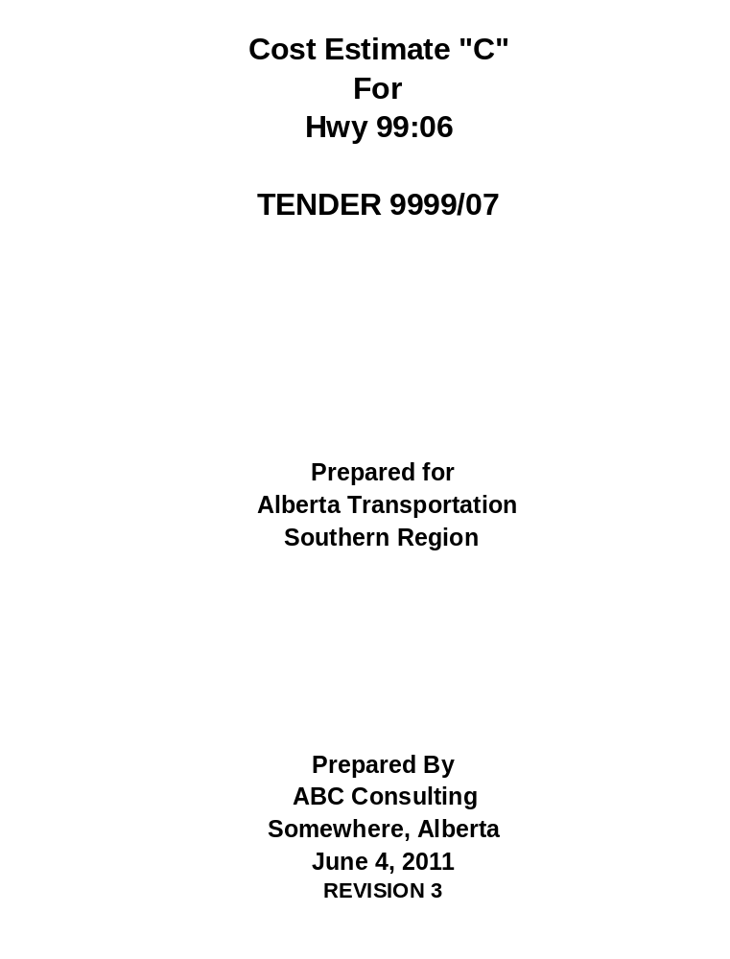

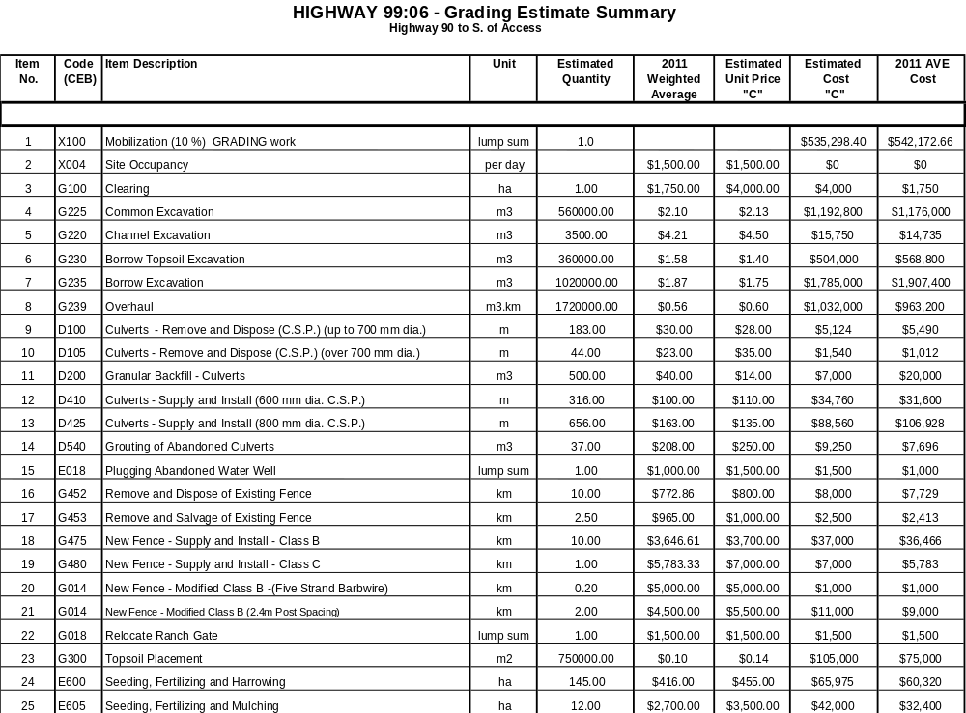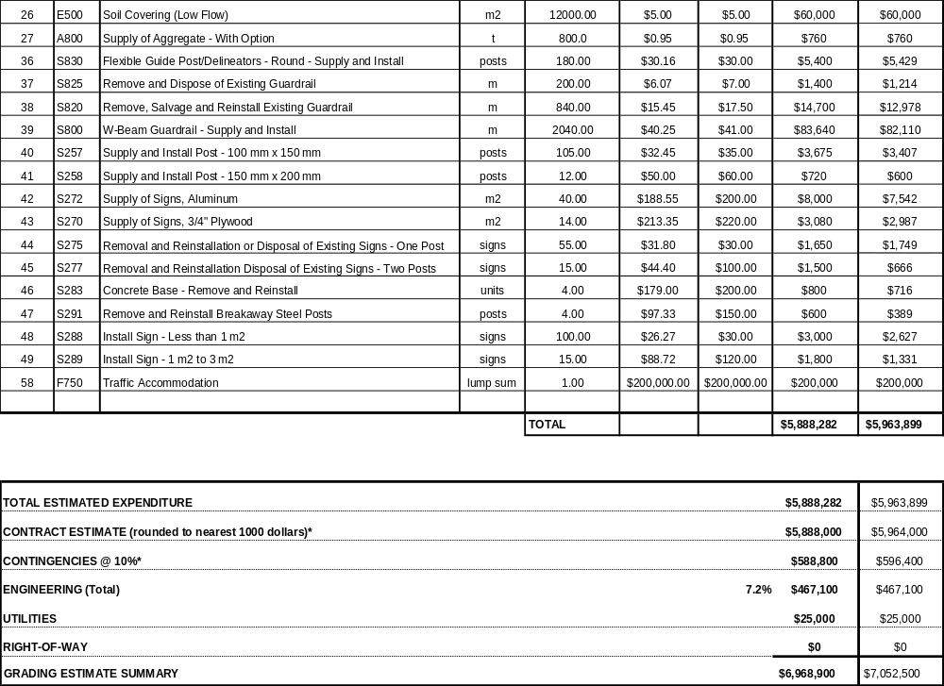

Bid
Code
Unit
Estimated
2011
Estimated
Estimated
2011 AVE
No.
(CEB)
Quantity
AVE
Unit Price
Cost
Cost
"C"
"C"
1
X100
Mobilization (10 %) ACP
lump sum
1.0
$212,562.50
$203,328.45
2
X004
Site Occupancy
per day
$1,500.00
$1,500.00
$0.00
$0
27
A800
Supply of Aggregate - With Option
t
78000.0
$0.95
$0.95
$74,100.00
$74,100
28
Q185
Gravel Surfacing
t
10000.0
$3.80
$5.00
$50,000.00
$38,000
33
Q487
Asphalt Concrete Pavement - EPS Mix Type 1
t
67000.0
$27.20
$28.25
$1,892,750.00
$1,822,400
34
Q510
Asphalt Mix For Others
t
1000.0
$23.40
$24.00
$24,000.00
$23,400
50
S310
Pavement Message Markings - Turn Arrow (Single or Double)
units
17.0
$41.24
$50.00
$850.00
$701
51
S315
Pavement Message Markings - Stop Bar
units
4.0
$51.55
$75.00
$300.00
$206
53
S350
Roadway Lines - Supplying Paint and Painting (Directional Dividing and 2 Edge Lines)
km
23.5
$452.11
$500.00
$11,750.00
$10,625
54
S355
Roadway Lines - Supplying Paint and Painting (Lane Dividing Lines)
km
7.5
$202.11
$250.00
$1,875.00
$1,516
55
S360
Intersection Lines - Supplying Paint and Painting
intersections
2.0
$168.39
$250.00
$500.00
$337
56
X510
Cutting of Pavement Edge
m
10000.0
$5.00
$5.75
$57,500.00
$50,000
57
S052
Remove and Dispose Advance Warning Signs
units
2.0
$6,000.00
$6,000.00
$12,000.00
$12,000
TOTAL
$2,338,188
$2,236,613
TOTAL ESTIMATED EXPENDITURE
$2,338,188
$2,236,613
CONTRACT ESTIMATE (rounded to nearest 1000 dollars)*
$2,338,000
$2,237,000
CONTINGENCIES @ 10%*
$233,800
$223,700
ENGINEERING (Total)
$67,431
$67,431
UTILITIES
$0
$0
RIGHT-OF-WAY
$0
$0
TOTAL ESTIMATE HIGHWAY 99:06 - ACP
$2,639,231
$2,528,131
HIGHWAY 99:06 ACP ESTIMATE SUMMARY
Highway 90 to S. of Access
Item
Code
Item Description
Unit
Estimated
2011
Estimated
Estimated
2011 AVE
No.
(CEB)
Quantity
AVE
Unit Price
Cost
Cost
"C"
"C"

1
X100
Mobilization (10 %) GBC
lump sum
1.0
$138,795
112,312.96
2
X004
Site Occupancy
per day
$1,500.00
$1,500.00
$0
$0
27
A800
Supply of Aggregate - With Option
t
173000.0
$0.95
$0.95
$164,350
$164,350
29
B100
Subgrade Excavation
m3
500.0
$3.92
$4.00
$2,000
$1,960
30
B172
Granular Fill (Pit-run) 6 - 80
t
1000.0
$13.33
$14.00
$14,000
$13,330
31
B282
Granular Base Course 2-25
t
172000.0
$5.30
$6.80
$1,169,600
$911,600
TOTAL
$1,450,745
$1,171,663
TOTAL ESTIMATED EXPENDITURE
$1,450,745
$1,171,663
CONTRACT ESTIMATE (rounded to nearest 1000 dollars)*
$1,451,000
$1,172,000
CONTINGENCIES @ 10%*
$145,100
$117,200
ENGINEERING (Total)
5.2%
$84,944
$84,944
UTILITIES
$0
$0
RIGHT-OF-WAY
$0
$0
GBC ESTIMATE
$1,684,844
$1,377,454
HIGHWAY 99:06 - GBC ESTIMATE SUMMARY
Highway 90 to S. of Access
Bid
Code
Item Description
Unit
Estimated
2011
Estimated
Estimated
2011 AVE
No.
(CEB)
Quantity
AVE
Unit Price
Cost
Cost
"C"
"C"

59
X100
Mobilization (10 %) Bridge Structures
lump sum
1.0

253,468.25
250,708.37
60
X004
Site Occupancy
per day
$600.00
$600.00
$0
$0
61
F186
Excavation - Structural
lump sum
1
$40,000.00
$40,000.00
$40,000
$40,000
62
F190
Backfill
lump sum
1
$400,000.00
$400,000.00
$400,000
$400,000
63
F812
Supply of Piling - H-Pile
m
466
$62.89
$65.00
$30,290
$29,307
64
F816
Pile Set-up
piles
28
$1,191.24
$1,200.00
$33,600
$33,355
65
F818
Pile Driving
m
466
$4.00
$4.00
$1,864
$1,864
66
F018
Mechanically Stabilized Earth Wall
lump sum
1
$640,000.00
$640,000.00
$640,000
$640,000
67
F963
Supply of Girders - Precast Long Span - DBC Type (Exterior)
girders
4
$25,000.00
$25,000.00
$100,000
$100,000
68
F963
Supply of Girders - Precast Long Span - DBC Type (Interior)
girders
18
$25,000.00
$25,000.00
$450,000
$450,000
69
F940
Delivery of Girders
lump sum
1
$25,000.00
$25,000.00
$25,000
$25,000
70
F945
Erection of Girders
lump sum
1
$130,000.00
$130,000.00
$130,000
$130,000
71
F834
Concrete - Class C
m3
191
$619.00
$675.00
$128,925
$118,229
72
F840
Concrete - Modified Class SF
m3
382
$819.64
$850.00
$324,700
$313,102
73
F850
Plain Reinforcing Steel - Supply
kg
29227
$0.83
$0.85
$24,843
$24,258
74
F852
Epoxy-coated Reinforcing Steel - Supply
kg
33188
$1.32
$1.35
$44,804
$43,808
75
F854
Reinforcing Steel - Place
kg
62415
$0.41
$0.45
$28,087
$25,590
76
F905
Supply of Bearings
lump sum
1
$10,000.00
$10,000.00
$10,000
$10,000
77
F780
Bridge rail
lump sum
1
$79,700.00
$79,700.00
$79,700
$79,700
78
F020
Tube Rail Fence
m
215
$40.00
$40.00
$8,600
$8,600
79
F965
Ducts
lump sum
1
$5,200.00
$5,200.00
$5,200
$5,200
80
F970
Miscellaneous Iron
lump sum
1
$10,000.00
$10,000.00
$10,000
$10,000
81
F842
Sealer
lump sum
1
$10,000.00
$10,000.00
$10,000
$10,000
81
F022
Ditch Lining
m2
800
$2.00
$2.00
$1,600
$1,600
82
F022
Sacked Concrete Drain Troughs
m
166
$45.00
$45.00
$7,470
$7,470

TOTAL

$2,788,151
$2,757,792
TOTAL ESTIMATED EXPENDITURE
$2,788,151
$2,757,792
CONTRACT ESTIMATE (rounded to nearest 1000 dollars)*
$2,788,000
$2,758,000
CONTINGENCIES @ 10%*
$278,800
$275,800
ENGINEERING
$166,276
$166,276
UTILITIES
$0
$0
RIGHT-OF-WAY
$0
$0
TOTAL ESTIMATE HIGHWAY 99:06 CPR OVERPASS
$3,233,076
$3,200,076
HIGHWAY 99:06 CPR OVERPASS BF 99999 N and BF 99999 S ESTIMATE SUMMARY
Bid
Code
Item Description
Unit
Estimated
2011
Estimated
Estimated
2011 AVE
No.
(CEB)
Quantity
AVE
Unit Price
Cost
Cost
"C"
"C"
1
X100
Mobilization (10 %) ACP
lump sum
1.00
$54,169
$52,203
2
X004
Site Occupancy
per day
$1,500.00
$1,500.00
$0
$0
29
B100
Subgrade Excavation
m3
250.00
$3.92
$4.00
$1,000
$980
30
B172
Granular Fill (Des 6-80)
t
500.00
$13.33
$14.00
$7,000
$6,665
27
A800
Aggregate Supply With Option
t
17500.00
$0.95
$0.95
$16,625
$16,625
33
Q487
Asphalt Concrete Pavement - EPS Mix Type H1
t
17000.00
$27.20
$28.25
$480,250
$462,400
38
S820
Remove, Salvage and Reinstall Existing Guardrail
m
138.00
$15.45
$17.50
$2,415
$2,132
35
G270
Side slope Improvement
km
3.00
$9,186.15
$9,200.00
$27,600
$27,558
50
S310
Pavement Message Markings - Turn Arrow (Single or Double)
units
18.0
$41.24
$50.00
$900.00
$742
52
S315
Pavement Message Markings - Stop Bar
units
6.00
$51.55
$75.00
$450
$309
52
S321
Pavement Messages - STOP
units
6.00
$383.21
$450.00
$2,700
$2,299
53
S350
Roadway Lines - Supplying Paint and Painting (Directional
Driving and 2 Edge Lines)
km
4.00
$452.11
$500.00
$2,000
$1,808
55
S360
Intersection Lines - Supplying Paint and Painting
intersections
3.00
$168.39
$250.00
$750.00
$505
TOTAL
$595,859
$574,228
TOTAL ESTIMATED EXPENDITURE
$595,859
$574,228
CONTRACT ESTIMATE (rounded to nearest 1000 dollars)*
$596,000
$574,000
CONTINGENCIES @ 10%*
$59,600
$57,400
ENGINEERING (Total)
$33,311
$33,311
UTILITIES
$0
$0
RIGHT-OF-WAY
$0
$0
TOTAL ESTIMATE HIGHWAY 99:06 - ACP - Final Stage Paving
$688,911
$664,711
HWY 99:06 ACP (FINAL STAGE) ESTIMATE SUMMARY
S. of Access - N. of Anytown

Estimated
2011 AVE
Cost
Cost
"C"
TOTAL ESTIMATED EXPENDITURE*
$13,099,225
$12,736,085
CONTRACT ESTIMATE (rounded to nearest 1000 dollars)*
$13,099,000
$12,737,000
CONTINGENCIES @ 10%*
$1,309,900
$1,273,700
ENGINEERING (Total)
6.3%
$819,062
$819,062
UTILITIES
$25,000
$25,000
RIGHT-OF-WAY
$0
$0
TOTAL CONTRACT ESTIMATE - ALL PHASES COMBINED
$15,252,962
$14,854,762
*Note: Total Estimated Expenditure values vary from individual estimate summaries due to rounding.
Prepared By:
Person 1, Transportation Engineer
Checked By:
Person 2, Sr. Project Manager
Date
October 11, 2011
Checked By:
Person 3, RET Project Manager
Revision 3 - Final Check Revised Costs for Engineering and Combining Quantities.
TOTAL HIGHWAY 99:06 Cost Estimate "C" Summary



