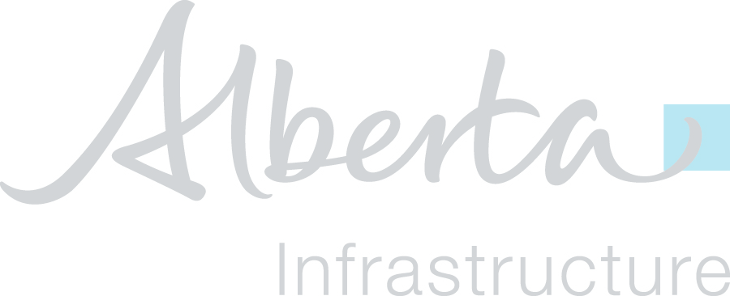
Alberta Infrastructure

Digital Project Delivery
Asset Information Management Execution Plan Template

Table of Contents
1. Project Information 3
2. Organization Roles and Staffing 3
2.1 AIM Contacts 3
2.2 AIM Roles and Accountabilities 3
3. Project Challenges 3
4. Collaboration Procedures 4
4.1 Collaboration Strategy 4
4.2 Collaboration Software 4
4.3 Collaboration Meetings 4
5. Quality Control 4
6. Technology Infrastructure 4
7. AIM Deliverables 5
8. Reality Capture 5

Instructions
This document is provided to form the basis of the minimum requirements of a project Asset Information Management (AIM) Execution Plan (AEP). The AIM Manager shall utilize this template to develop the AEP and provide to the Province for review and confirmation of acceptance. The provided template may contain sections or elements that are not applicable to every project condition. The AIM Manager shall add or modify sections as required.

- Project Information
Briefly describe the project:
    - Facility Owner: Alberta Infrastructure
    - Project Location/Address: 123 Example Street NW, Edmonton, AB, T1N1N1
    - Project Name: HQ Office Tower
    - Contract Type: Design-Build
    - Facility Type: Commercial Office Facility
    - Project Description: 5 storey office tower and training facility
    - Project Number: (AI Project ID#)
- Organization Roles and Staffing
  - AIM Contacts
List the key AIM contacts and their contact information for the project. This list shall be updated as project team members are added or removed during the project lifecycle.
Discipline | Name | Organization | Email | Phone

  - AIM Roles and Accountabilities
Describe AIM roles and accountabilities such as AIM Manager, Project Managers, and Quality Control (QC) Managers. Include an organizational chart indicating the AIM Manager and the discipline/sub-trade AIM leads. Indicate whether the project team is located centrally or in various locations.
Role | Name | Organization | Responsibilities

- Project Challenges
Identify project challenges which may influence the approach to Asset Information Management.
- Collaboration Procedures
  - Collaboration Strategy
Describe how the project team shall collaborate in development and coordination of asset information. Include items such as electronic communication requirements and procedures, document management, transfer, updating and storage.
  - Collaboration Software
Identify all software used to share and coordinate asset information.
Software | Storage Type | Collaboration Use | Project Member | Version

  - Collaboration Meetings
Define all meetings and collaboration sessions that shall be held throughout the project. Identify the project stage the meetings shall be held in, the frequency of the meetings, the participants required, and the location of the meeting.
Meeting | Project Stage | Frequency | Participants | Location

- Quality Control
Describe the methods and workflows to control the quality and accuracy of the Construction Operations Building information exchange (COBie) data, including manual and automated processes of Data Validation and Data Verification.
- Technology Infrastructure
List all software and add-in programs that shall be used to create the COBie deliverable.
Software | Version | Storage Type | Collaboration Use | Project Member

- AIM Deliverables
Identify the delivery plan for AIM deliverables. Include the frequency that updates shall be provided to the Province.
Submittal Item | Project Stage | Format | Responsibility | Due Date | Notes

- Reality Capture
Identify the reality capture plan and how and what each team member is responsible for delivering. Include the frequency the capture shall take place, how the files shall be stored and organized, and define the minimum quality requirements, technology used, training required, and the image resolution standard for the capture.

