**Falconry Collection Licence**

**Application**

**Note to applicants:**

* For all applications: please complete sections 1 and 2

**Section 1 –** **Information**

|  |
| --- |
| Falconry species desired for collection: |

|  |  |  |  |
| --- | --- | --- | --- |
| Name of person collecting falconry species: | | | |
| Address: | | | |
| City/Town: | | Prov/Territory | Postal Code: |
| Phone: | Cell Phone: (not required) | | Fax: |
| E-mail Address: | | | |
| Detail experience relative to proposed falconry collection: | | | |

|  |  |  |  |
| --- | --- | --- | --- |
| Name of additional person assisting falconry collection: | | | |
| Address: | | | |
| City/Town: | | Prov/Territory | Postal Code: |
| Phone: | Cell Phone: (not required) | | Fax: |
| E-mail Address: | | | |
| Detail experience relative to proposed falconry collection: | | | |

**Privacy Statement**

Information you provide to Alberta Environment and Parks (AEP) is collected under the authority of Section 33(c) of the *Freedom of Information and Protection of Privacy* (FOIP) *Act* and is managed in accordance with Part 2 of the (FOIP) Act. Your personal information (name, address, phone number, e-mail address) will be used by the Fish and Wildlife Policy Branch and AEP Operations for the purpose of communication with you about your Falconry Collection Licence and application.

Your personal information will not be used or disclosed for any other purpose by AEP without your consent or unless required to do so by law.

Should you wish to have your personal information removed or corrected or have concerns pertaining to your Falconry Collection Licence or application, please contact Gordon Court at:

* [Gord.Court@gov.ab.ca](mailto:Gord.Court@gov.ab.ca)

|  |  |  |  |
| --- | --- | --- | --- |
| Name of additional person assisting falconry collection: | | | |
| Address: | | | |
| City/Town: | | Prov/Territory | Postal Code: |
| Phone: | Cell Phone: (not required) | | Fax: |
| E-mail Address: | | | |
| Detail experience relative to proposed falconry collection: | | | |

|  |
| --- |
| Name All Additional Participants. |

|  |
| --- |
| Detail falconry collection proposal, including capture methods and age of bird to be collected. Please include sufficient information for the Licence Issuer to understand what is proposed. |

**CLASS PROTOCOL for Falconry:**

As part of the original mandate for the Wildlife Animal Care Committee (ACC), it was determined that ongoing, repeated activities associated with handling live wildlife should be managed so as to avoid unnecessary review. To this end, the Wildlife ACC, in conjunction with staff and individuals involved in the activities in Alberta developed “Class Protocols” that outline a standardized set of approved methods to cover specific activities.

**Class Protocol #001 Raptor Collection for Falconry**

This Class Protocol has been adopted by the Wildlife ACC and approved by the Fish and Wildlife Division as conditions on appropriate licenses to collect raptors for falconry. Failure of the permittee/licencee to abide by the protocol standards will render the permit/licence invalid. Alberta’s Class Protocols can be found at:

* [**Wildlife Research and Collection**](http://aep.alberta.ca/fish-wildlife/wildlife-research-collection/default.aspx)

I agree to abide by the standards outlined in (please check box below to indicate agreement):

Class Protocol #001 Raptor Collection for Falconry

Referring to the map below, select any Environment and Parks Operations Region within which the proposed falconry collection will occur (check all applicable areas).

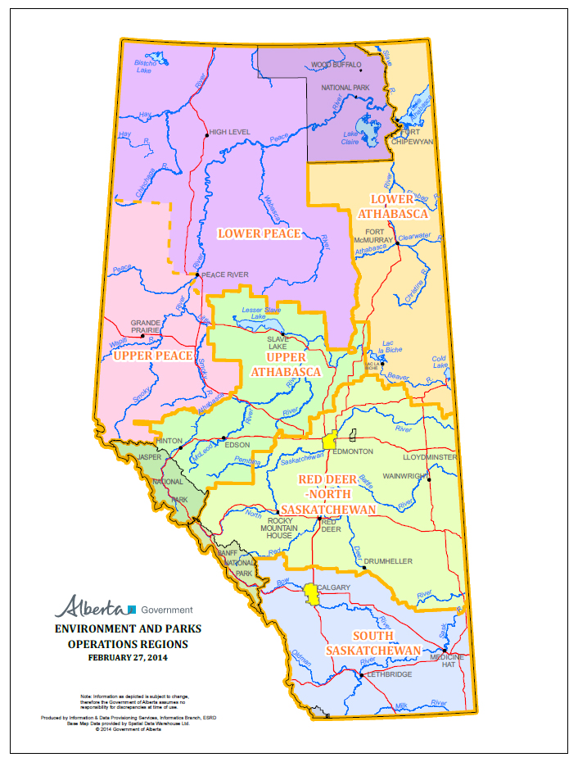

**Upper Peace**

**Lower Peace**

**Upper Athabasca**

**Lower Athabasca**

**North Saskatchewan/Red Deer**

**South Saskatchewan**

**Section 2 –** **Declaration and Submission:**

**Declaration:**

I hereby declare that the methods and procedures as provided in my application for a Falconry Collection Licence will be maintained throughout the duration of collection activities. I understand that, I require a Falconry Permit in addition to this Collection Licence to collect a falconry bird from the wild and that it is my responsibility to obtain the Falconry Permit each year.

**This form accepts electronic signatures. In order to use the electronic signature, double click in the space after the X on the signature line below, then click on OK, and follow subsequent instructions.**

Date: Click here to enter a date.



**Submission Instructions:**

* Are ALL participants in the project named in the application?
* Are all relevant details included, such as locations where you will be conducting collection activities?

TO E-MAIL APPLICATION: Save the completed application by using "Save as" under the "File" directory, then attach to an e-mail addressed to:

* [Gord.Court@gov.ab.ca](mailto:Gord.Court@gov.ab.ca).

Please use "Falconry Collection Licence Application" in the subject line of the e-mail.

Save a copy on your computer for your future reference.

For postal submission, mail one (1) copy of the application plus relevant additional documentation to:

**Gord Court**

**Environment and Parks**

**2nd Floor, Great West Life Building**

**9920-108 Street**

**Edmonton, AB T5K 2M4**