Modular Classroom Prep Sheet

Instructions: In preparation for the receipt of your new modular classrooms, please provide your regional representative with the following information for each school site that is to receive new modular classrooms:

Core Information:
Name of School Board: | Select a School Board.
Name of School Board Contact: | Click here to enter text.
School Board Contact Phone No, Email Address: | Click here to enter text.
Name of Receiving School: | Click here to enter text.
School Address: | Click here to enter text.
Project Type: | MCP: ☐ | AI Managed: ☐ |  | Grant Funded: ☐
Date Units Required for Pick up: | Click here to enter a date.
Procurement Strategy: | Tender: ☐ |  | Own Forces: ☐

Important Notice: Prep Sheets must be submitted with a “Required by Date”. Storage fees accumulate at a rate of $100 per business day per unit commencing 60 days after the “Required by Date” as indicated above and on the Purchase Order. If Own Forces has been selected please see the Own Forces Responsibility Checklist below.

Please use the chart below to identify the number of modular classrooms of each type that are required.
(See Page 4 for unit type reference)

Unit Type: | Type A |  |  |  |  |  |  |  |  |  |  |  | Type B
 | A1 | A2 | A3 | A4 | A5 | A6 | A7 | A8 | A9 | A10 | A11 | A12 | B
Standard Duty | No. | No. | No. | No. | No. | No. | No. | No. | No. | No. | No. | No. | No.
Heavy Duty | No. | No. | No. | No. | No. | No. | No. | No. | No. | No. | No. | No. | No.
Washroom | No. | No. | No. | No. | No. | No. | No. | No. | No. | No. | No. | No. | No.
Vestibule | No.

Options: | Select Options
Sprinklers | ☐
Air Condensing Unit | ☐
Millwork | ☐
Millwork and Sink | ☐

Modular Classroom Prep Sheet

Site Plan:
A site plan, fully dimensioned, of the entire site showing school, the location and orientation of the modular classrooms, connecting link (if required) and site access points. The site plan should identify the type of modular classrooms (A-Unit Type and Orientation and/or B-Unit).

Important Notice:
For all modular classrooms approved under the Modular Classroom Program (MCP), if the Modular Classroom Prep Sheet has not been received prior to March 31, 2023, your unit(s) are not guaranteed to be on site for the 2023/2024 School Year.

Please email a completed checklist along with the site plan to Alberta Infrastructure:
Program Management and Integration – Infras.MCP@gov.ab.ca

Cost Estimate: Only required to be completed for orders as part of The Modular Classroom Program (MCP). Please double click to enter information into the below excel table.

Modular Classroom Prep Sheet
Modular Classroom Prep Sheet

Own Forces Responsibility Checklist: Only to be completed and checked off by School Jurisdictions that elect to utilize The Own Forces delivery method (as per the School Capital Manual).
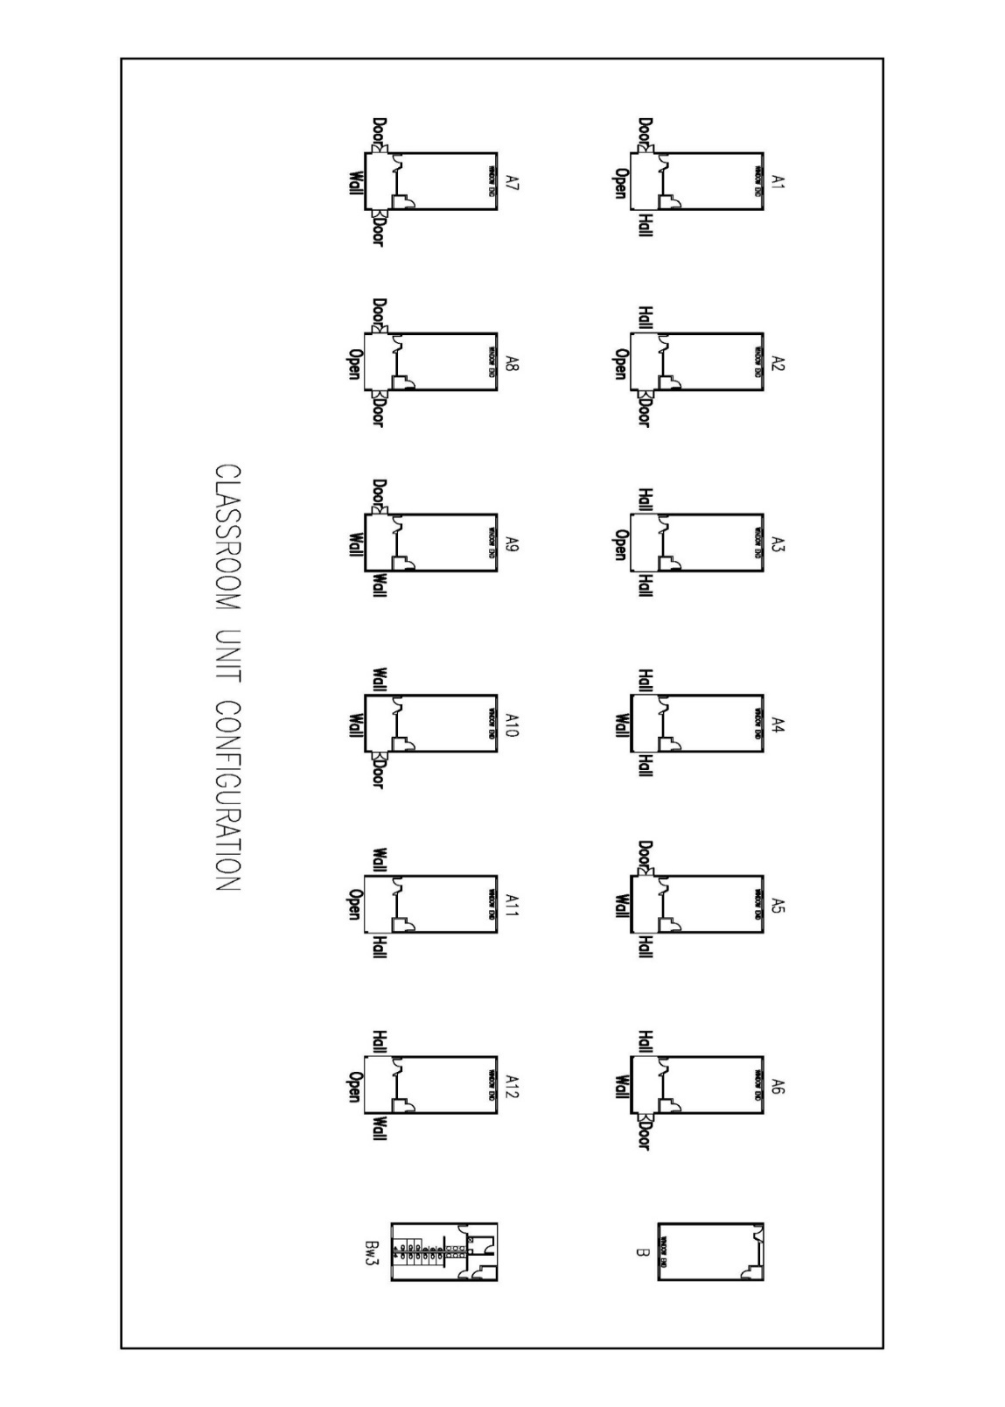
School Jurisdictions utilizing the Own Forces delivery method are responsible to:
☐ | - Acknowledge the risks and responsibilities to the school jurisdiction when acting as the prime contractor;  - Obtain and submit to Infrastructure confirmation of site and liability insurance for the project;  - Provide confirmation that appropriate permits have been or will be obtained; and  - Provide rationale to Infrastructure for the use of the Own Forces delivery method submitted with the completed prep sheet.

Classroom Unit Configuration:

