

Pest Control:

Background Information
Pests, including insects and rodents, can be a source of bacteria, disease and physical contamination. Having comprehensive pest control measures will help reduce or eliminate pest activity within and around the facility and minimize the associated risks of infestations and/or product contamination risk.
Section E2 of the Meat Facility Standards (MFS) 2022 describe the requirements for effective pest control.
Meat Facility Standards (MFS) 2022
E2.1 Pest Control
The facility ensures that effective pest control is in place including:
- Pest control devices are effectively placed and used to ensure no pest entry.
- Pest control devices and/or pest control chemicals are used and maintained appropriately for the area(s) they are being used.
- Pest control chemicals are stored in a secure area and in a manner that does not cause cross-contamination risk to food, food processing or packaging.
- Pest Control Monitoring Records.

Effective Pest Control Considerations
Effective pest control measures are those that prevent pests from entering a facility, detecting pest activity early, and eliminating pests quickly before facility infestation and/or environment or food contamination becomes a real concern. The key outcome to be met is that there is no evidence of pest infestation.
If pests are found inside the facility on more than a rare, isolated occurrence, there is a problem. Pest control measures are not effective if this is the case and must be reviewed and improved.
The following considerations apply to the facility's premises and are essential to preventing pest entry:

Exterior Premises
- Facility surroundings must be kept free of debris, clutter, vegetation, and standing water, all of which provide harborage and attract pests.
- Exterior lighting should be positioned away from the building to reduce insect (e.g. fly) swarming near entry points.
- Garbage and waste (including animal waste) containers must be adequately sized, covered, and emptied frequently (e.g. Daily) to prevent overflow and pest attraction.
- All paved or graded areas should be well-drained and maintained to prevent pooling water.

Building Structure and Entry Points
- All doors, windows, and other openings must be tight-fitting and kept closed when not in use; screens must be in good repair (minimum 16-mesh for insect exclusion).
- Cracks, crevices, and gaps aro und pipes, conduit, and other penetrations must be sealed to eliminate both entry points and harborage sites.
- Roofs, gutters, and wall surfaces must be maintained in good repair and kept free of debris.

Interior Operations
- Spills must be cleaned immediately; routine cleaning is essential to remove food residues that attract pests.
- All food and materials in the facility must be stored in designated storage areas in a non-cluttered and organized manner.
- All food and materials must be stored off the floor on clean well-maintained shelving or pallets, with clear aisles maintained along walls and between aisles to allow for inspection.
- Stock rotation must be practiced to reduce buildup of old product.
- Incoming ingredients and materials must be inspected for signs of infestation upon receipt.

Other Considerations:
- Routine inspection allows for early detection. Particular focus is required in areas where pests are most likely to occur, such as receiving docks, lairage and live receiving, inedible rooms, storage areas, employee break rooms, lockers, and potential entry points.
- Root cause analysis identifies factors that may attract or harbour pests, such as food residue, inadequate cleaning, structural gaps, standing water, or debris accumulation on the exterior premises.
- Pest treatments must not pose a risk to workers, food products, or the environment, and must be applied in accordance with all applicable regulations.
- Communication and cooperation is crucial between the designated facility workers responsible for pest control and any contracted pest control providers (if contracted providers are used).
- Recordkeeping is required of all pest control monitoring activities to demonstrate the effectiveness of measures and to identify areas requiring additional attention

Pest Control Devices

Rodent Control

Indoor Traps
- Best practice is to place metal live traps on either side of every outside opening wherever possible (ie. the facility layout is conducive to it) it;
- Traps must be accessible and in good working order at all times
- Snap traps, rodent sticky tapes or any other type of open trap are not acceptable inside the facility.
- Homemade traps are not acceptable.

Exterior Bait Stations
- Best practice is to install anchored, enclosed bait stations with fresh bait inside
- Bait stations should be placed near entrances to the facility and in other areas that attract pests.
- Poisons and/or bait stations are not acceptable for use inside a facility.

Insect (e.g. Fly) Control

Insect Traps
- Best practice is to place light traps at eye level in lairage and barns, in or near inedible-waste rooms, receiving docks, etc.;
- The number of insect control stations must be adequate to ensure that the presence of all insects (including flies) are a rare occurrence inside the facility.
- Insect control is very important in the barn (lairage) and where animals are housed prior to entering the facility.
- Hanging fly tape is not acceptable for use inside a facility; and
- Ant hotels are not acceptable for use inside a facility because they contain poison.

Chemicals
Chemicals used for pest control include pesticides and baits. All pest control chemicals must be used in accordance with the manufacturer’s instructions.
Pesticides must be approved for specified use. Approval can be shown using the Pest Control Product (PCP) Registration Number, issued by Health Canada’s Pest Management Regulatory Agency (PMRA). The PCP number can be found in:
- Product label
- Safety Data Sheets (SDS) in Section 1 (Product Identification) or Section 15 (Regulatory Information)
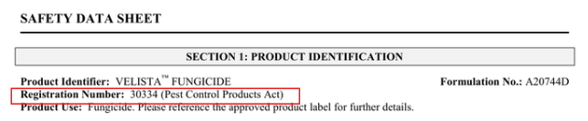
Figure 1 PCP Registration number in SDS
- Health Canada’s Pesticide Product Information Database
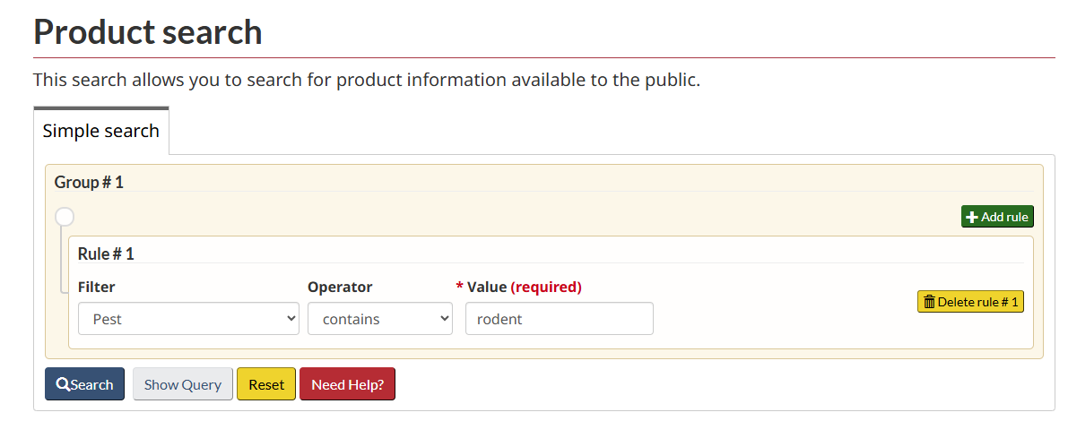
Figure 2 Product search for registered Pest Control Product (PCP) for rodents in Health Canada’s Pesticide Product Information Database
When chemicals for pest control are used in the facility (e.g. through fogging, sprays, etc)., all food contact surfaces in proximity must be thoroughly washed and rinsed before resuming operations.
Pest control chemicals must be stored in a safe, segregated area away from any packaging or food product.

Pest Control Program
A written procedure for Pest Control is highly recommended as it can be useful in effective pest control. A ‘Pest Control Program’ should include the following:
- Who will be conducting pest control checks – company workers or an outside contractor* (if an outside contractor, a contact name and number must be included);
- Chemicals used, and concentration of chemicals used
  - This includes any herbicides or pesticides that may be sprayed in the vicinity of the facility for pest or weed control
  - Directions for use must be stated and followed.
  - All chemicals used must be approved for the stated purpose
  - Controlled pesticides must be applied by a licensed pest control operator
- Types, number, and placement of traps. Include a current facility map, including any exterior bait stations;
- Frequency of pest activity checks;
- Monitoring procedure;
- Deviation and corrective action procedures;
- Records associated*; and
- Verification.
*If a contractor is used to provide pest control, the pest control record may be maintained by the contractor but must be kept on file at the facility.

Pest Control Monitoring Record
A pest control monitoring record is required and must show:
- Date the traps were checked;
- Trap types, number and activity, i.e. Number of pests found in each trap;
- Deviation and corrective actions;
- Monitor’s initials or signature; and
- Verifier’s initials or signature.
The use of pesticides, including use of rodent control baits should be recorded in a ‘Record for pesticide usage’. This record includes:
- Product name
- PCP registration number
- Concentration used
- Location of application (Example: Bait station #1)
- Date and time of application
Pest device maps are not mandatory but help to indicate the device location and type of trap (E.g. Insect light trap, multi-catch device, exterior bait station, etc.) for easier monitoring.

Review of Pest Control Program
The pest control program must be updated as changes occur (e.g. new chemical used or traps added). In addition, an annual review by the operator is required. The review must be documented: this could be shown by the operator or designate “signing off” (with date of review) the procedure or using a more formal review checklist.

