Company Name/logo | Water Activity Meter Calibration Procedure Example | Version No.: 01
Effective Date: mm-dd-yyyy | Approved by: [Insert Manager/ Supervisor responsible] | Revision Date: mm-dd-yyyy

Purpose:
To ensure the facility has an effective calibration program for water activity meters assuring food safety critical limits are being met.

Who:
Outside Contractor/Kill Floor Supervisor/Operator

Frequency:
- Once per shift or daily before use.
- Annual

Procedure:
Portable WATER ACTIVITY METER PAWKIT (example)
- Using a vial of the 0.760 aw NaCl standard, empty the entire contents of the vial into a sample cup.
- Place the PAWKIT over the sample cup.
- Press the I button to take a reading. If it is reading the correct water activity (± 0.02), the PAWKIT needs no adjustment for this standard.
- Verify with a second standard, either the 0.25 or the 0.92 standard. Choose the standard that is closest to the water activity range of the sample material being tested. In other words, if it is normally higher than 0.76 aw , use the 0.92 standard. If it is normally lower than 0.76 aw , use the 0.25 standard. If the PAWKIT measures the second standard correctly (±0.02), begin testing the product.

Deviation and Corrective Action Procedures:
- If the first reading was not the correct water activity (±0.02), clean the PAWKIT and retest. If the second reading is the correct water activity (±0.02), the PAWKIT needs no adjustment at this time. If the second reading is not correct, adjustment is required.
- Press the II button (on the right) once to get the Calibration Mode screen. Once the reading is finished, the II button (on the right) activates. The II button is only active until the PAWKIT shuts itself off.
- Adjust the calibration.
  - Scroll to the proper screen for calibration adjustment.
  - Press the I button to adjust the correct value. Each time the I button is pressed, the value in the corner changes by an increment of 0.01.
- Store the new calibration value.
- Scroll to the proper screen for calibration adjustment.
- Press the II button to scroll until Sto appears in the lower right corner.
- Press the I button to store the new calibration value.
- Return to the main screen and begin a new measurement.
NOTE: If Stop is not pressed, no change is made to the PAWKIT calibration
- Verify with a second standard, either the 0.25 or the 0.92 standard. Choose the standard that is closest to the water activity range of the sample material being tested. In other words, if it is normally higher than 0.76 aw, use the 0.92 standard. If it is normally lower than 0.76 aw, use the 0.25 standard. If the PAWKIT measures the second standard correctly (±0.02), begin testing the product.
- If it does not measure correctly, repeat step 1 through step 5 for the second standard. If the calibration routine is inadvertently entered, keep pressing the II button until the main screen appears.
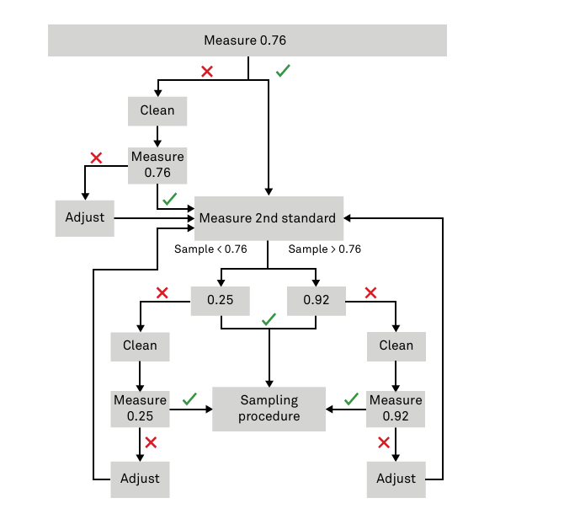
Figure 1: Calibration routine flowchart

Verification Procedures:
On a monthly basis, a designated Supervisor will:
- Review records documenting the calibration activities to ensure the proper version of the record is used, records are complete and filled out as per the written procedures.
On a semi-annual basis, a designated Supervisor will:
- Directly observe/ interview an employee performing calibration checks to ensure that the written procedures are being followed
- Directly observe corrective actions (where possible) taken by an employee to ensure that the written procedures are being followed.
Record verification activities will be documented on the Water Activity (Aw) calibration verification record.

Records:
- Water Activity (Aw) calibration verification record
- Calibration Certificates

Review:
This procedure will be reviewed annually and/ or updated whenever changes to facility operations, procedures, or processes occur that may affect its accuracy or effectiveness. It is the responsibility of the operator to ensure that all written programs reflect current practices and continue to achieve their intended food safety outcomes

8.1 Revision/ Review Log:
Version No. | Revision Date/ Annual review date | Description of Change | Revised/ Reviewed by

